Speed Density Tuning using Wideband O2 Input
Application: GM Gen 4 V8 with the E40 pcm & I4 based vehicles with the E12 PCM should also be able to use this guide for the most part.
Hopefully you’ve already worked out your idle & set your ifr table. If not start there & come back to this when that’s finished.
First things first…determine what the car is going to be used for mainly. This tuning guide is for semi mild setups as in the end we will be putting the car back in closed loop. If you plan on having a complete racecar that rarely or never sees the street an open loop speed density tune might be the answer. Also understand this is a very GENERAL guide to VE/Speed Density tuning for LS2’s and by no means is this the only way to do things.
Setting up your scanner
- Open the HPT Scanner.
- Open the Table portion to set up your PIDs
- The default config is a good starting point, from there just add:
Wideband Input ie LM1, LC1, PLX, etc…
Air Fuel Ratio Commanded Low Resolution
- Save the PID file as SD tuning.cfg by clicking on the Save Config file button
It should look similar to this
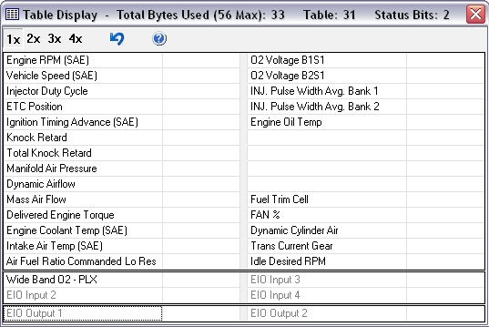

Set up Open Loop Speed Density
- VE tables can be tricky to setup from the start but a general guideline would be on a mild bolt on car leave it stock to start out. On a heads/cam setup you might need to lower your numbers in your idle cells as much as 40% & raise them as much as 20% in the upper WOT cells.
- Under Fuel Cutoff/DFCO set DFCO enable temp to 493°F & disable temp to 493°F. Then set the enable & disable RPM to 8192 this is so deceleration fueling wont effect the tuning process. Under normal conditions the computer leans out the a/f mixture when you let off the gas which can skew the numbers you gather for tuning your VE table.
It should look like this
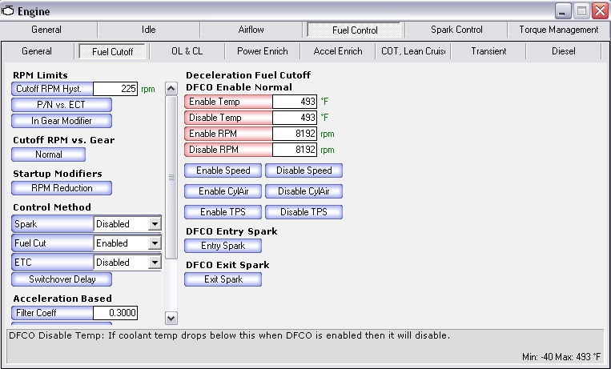
- Under Power Enrichment set the EQ ratio vs. RPM to your desired a/f across the board. This will keep your engine safe & make for one less step once you go back into closed loop. Again the numbers shown are very generic & will aim for ~13.0:1 a/f in PE mode.
It should look similar to this
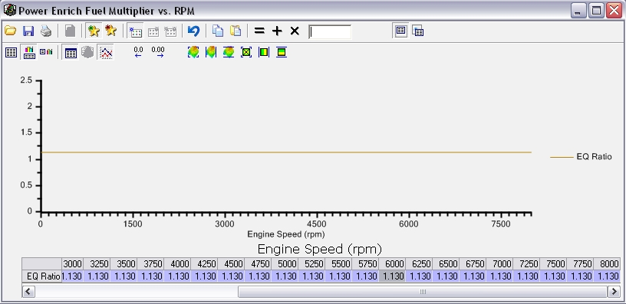

- Under Fuel Control-Open & Closed loop there are several tables that derive the final EQ ratio what you’ll need to do is get that final EQ ratio to be 1.0 which will ultimately give you a commanded a/f ratio of 14.7:1. Basically it takes the Mode that the vehicle is in with the fuel its using ie Gas(P/N) or Gas(Gear), etc. and multiplies that by the Airflow Gain tables cell then multiplies that by the IVT gain tables cell then multiplies that by the InjTemp Gain tables cell to come up with your final EQ ratio. For simplicity though you can just set all of these tables to 1.0 so that 1 x 1 x 1 x 1=1 then just make sure the EQ min table is set to 1.0 in the cells where you’ll be at operating temp and your good to go. Again it may look complicated but it really isn’t its just simple multiplication to come up with your final number.
Here are the tables I’m talking about these are the 4 “Mode” tables Alcohol & Gas, P/N & Gear
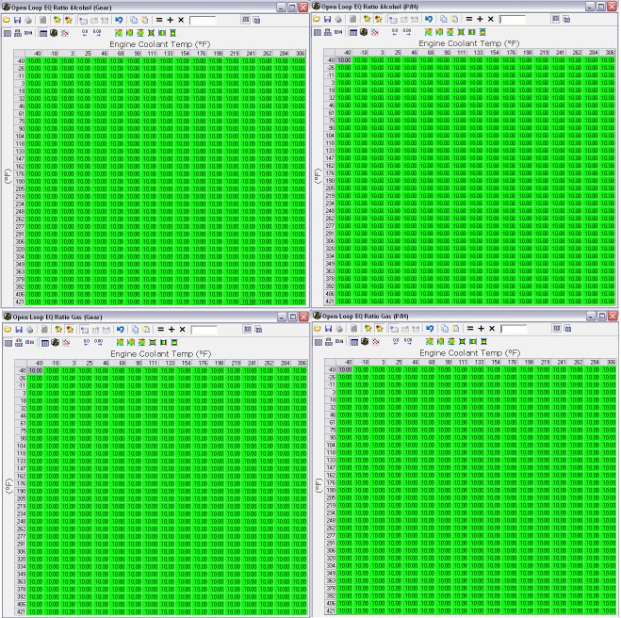
And here are the other multipliers as well as the EQ Ratio Minimum table.
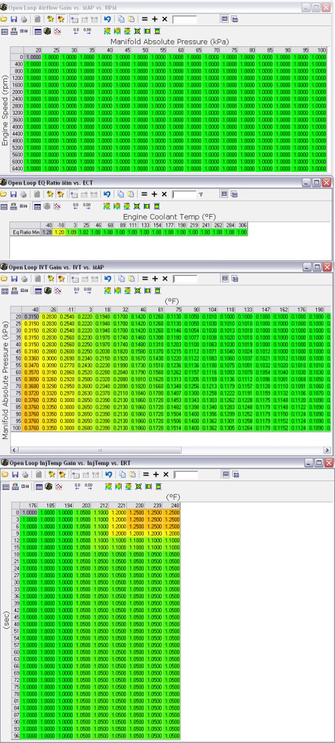

- Next disable your Long Term Fuel Trims by setting the min ECT to 493°F & the max ECT to -40°F
Like this
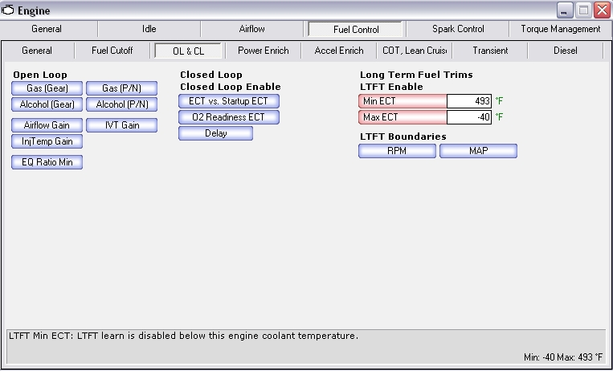
- Then set All Closed Loop Enable Temp cells to 306°F & Closed Loop 02 Ready ECT to 493°F this will ensure you go into open loop.
Like this
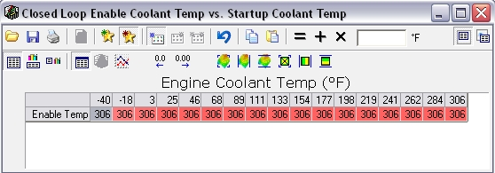
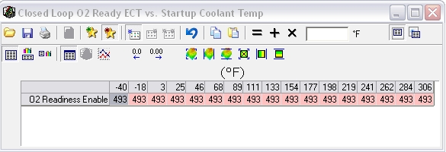
- Under COT, Lean Cruise set COT to Disabled. This is mainly to simplify the fuel tuning…the less adders & multipliers involved the better.
Caution: This can damage catalytic converters if you still have them on your car.
Like this
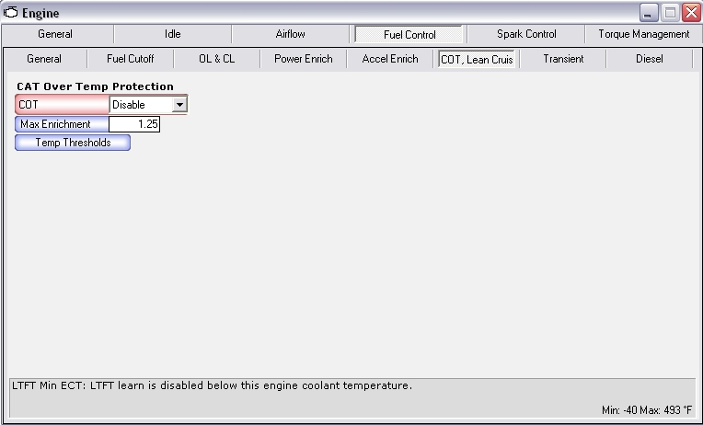

- Unlike Gen 3 pcm’s Gen 4 pcm’s such as the E40/E67/E38 when you go into Speed density mode the High & Low octane tables are both used so keep them as is for the time being.
- Set MAF Fail High Frequency to 0 & MAF Fail Low Frequency to 0
The PCM will detect a MAF fault as soon as you key on and thus revert to speed density mode.
The PCM requires a MAF DTC to be set to revert into speed density mode. If you set all of your MAF DTCs (101, 102, 103) to no error reported the PCM will not revert to speed density.
The factory settings will work but if you are concerned about an SES light, set the DTC's to No MIL Light. The PCM will still set the code for a MAF fault and thus still revert to speed density.
It should look like this
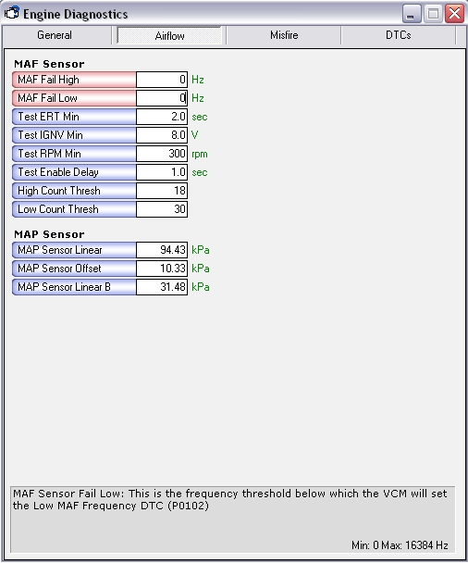
- Save this tune as SDStarter1.hpt and perform a calibration only reflash of this file into your PCM.

Data Logging
- Prepare your wideband for use with the usual preheating procedure.
- Start the engine and let it come up to full operating temperature.
- While the engine is warming up, start the HPT Scanner, connect to the vehicle and start monitoring your data (do not log at this time).
- Once the engine is warm (180 °F or higher), start your drive and start Data logging. Your driving style should be very calm. Avoid sudden throttle changes. The smoother you can make your driving style while covering as much of the histogram as you can, the better your results will be.
- While your doing your scanning you should also look over & evaluate your injector duty cycle…if your running over 90% you might want to consider stepping up in injector size before wasting too much time VE tuning.
- It helps to have a passenger viewing the AFR Error Histogram while it is displaying the cell count. You want to hit as many cells as you can, as many times as you can. Try to get a cell count of 50+ per cell.
It should look similar to this
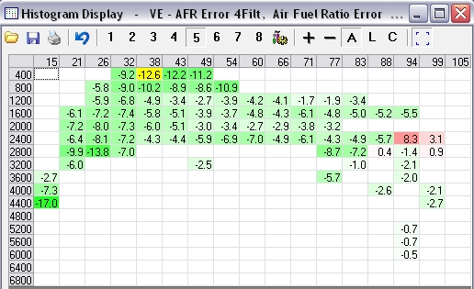
- After you have finished logging data, save the log file as SDtune1.hpl

Update .HPT File
- Start the HPT Editor & open SDStarter1.hpt
- Start the HPT Scanner & open and open SDtune1.hpl
- Open your pre-configured AFR error % histogram & set cell his required to 50, click average & load all data.
It should look similar to this once those minimum cell hits are filtered out
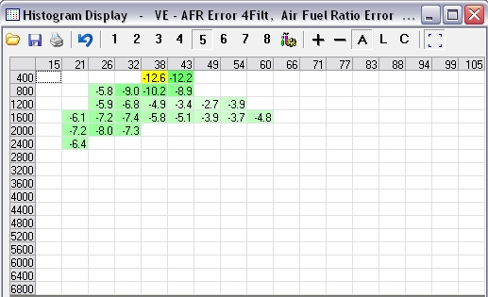

- Next highlight & copy all cells
- Switch to the SDStarter1.hpt file & open Primary VE table & paste special-multiply by % or half & hand blend the surrounding unaffected cells.
- While doing this it would be a good idea to adjust your spark tables for any KR you might be getting. Or add in spark where you think it could use it as to not skew your information too much later.
- Now Save your tune as: SDtune1.hpt & perform a calibration only reflash to the PCM
- If necessary repeat this until the average cell values in your AFR error map(s) are close to 0 (aim for +/- 1%).
.

Dialing in the MAF
- To re-enable the MAF simply set your MAF Fail frequency tables back to their original value and write it to the vehicle.
- You’ll need to use the high/low MAF histograms EC_Tune made which can be found here http://www.hptuners.com/forum/showpost.php?p=67485&postcount=2 or produce ones of your own. P12 applications use only a single MAF table so can use just the standard MAF table afr error histogram.
They should look similar to this
- Make sure you log MAF in Hz in the table and go for a drive.
- Hit as many of the cells as possible as many times as possible
- Copy & paste special-multiply % or half to your MAF airflow High & Low vs. frequency table & smooth make sure the last cell of the low matches the first cell of the high table(when applicable).
- Save & load new calibration
- Repeat if necessary
- Again the cells in the histogram should get closer & closer to 0% indicating 0% difference between actual AFR and commanded AFR.

Setting Everything Back to Closed Loop-MAF
- Open your Stock file
- Copy & paste your new, verified, VE primary, PE, & MAF tables in.
- Save file as & write calibration only the new file to the pcm

Verification
- Start the HPT Scanner and open the default config file also scan for the w/b & commanded a/f
- Start your engine and the Scan Tool and go for a drive
- Monitor Commanded AFR and WBO2 AF, they should be extremely close.
- Long-term fuel trims should eventually settle in the range –4 to 0
Thanks to all that helped with this write up.

